Technical Document


INVENTORY AND BILLING
MANAGEMENT SYSTEM

Developed by:



Technical Design Document version V1.0

Table of Contents

1. Introduction 1
1.1 Background 1
1.2 Objective 1
1.3 Scope 2
2. System Analysis 3
2.1. Identification of Need 3
2.2. Preliminary Investigation 3
2.3. Feasibility Study 3
2.3.1. Financial Feasibility 3
2.3.2. Technical Feasibility 3
2.3.3. Legal Feasibility 3
2.3.4. Operational Feasibility 4
2.4. Software Requirement Specification (SRS) 4
2.4.1. Purpose 4
2.4.2. Scope 4
2.4.3. Overall Description 5
2.4.4. Specific Requirement 5
B. Usability 6
C. Performance 6
D. Security 6
E. Help System Requirements 6
2.5. Software Engineering Paradigm Applied 7
2.5.1. Defining the Requirements 7
2.5.2. Prototype 7
2.5.3. Receive Feedback 8
2.5.4. Finalize Software 8
2.6. Data Models 8
2.6.1. Data Flow Diagram 8
2.6.2. Control Flow Diagram 10
2.6.3. Entity Relationship Model 11
2.6.4. Use-Case Diagram 13
3. System Design 16
3.1. Modularization details 16
3.1.1. Master Data 16
3.1.2. Utilities 16
3.1.3. Reports 16
3.2. Database Design, Data Integrity and Constraints 16
3.3. Test Cases 22
3.3.1. Unit Testing 22
3.3.2. Integration Testing 22
3.3.3. System Testing 22
3.3.4. Acceptance Testing 22
3.4. Procedural Design 26
4. System Security measures 29
4.1. Database/data security 29
4.2. List of triggers to maintain log 29
4.3. List of triggers to preventive Data manipulation 29

List of Table
Table 1 SRS Version Control 4
Table 2 Login 16
Table 3 Module 17
Table 4 Sub-module 17
Table 5 Sub-Module Permission 17
Table 6 Pages 17
Table 7 Agent 17
Table 8 Area 18
Table 9 Bank 18
Table 10 Employee 18
Table 11 Customer 19
Table 12 District 19
Table 13 Fiscal year 19
Table 14 General ledger 19
Table 15 Group 20
Table 16 Log table 20
Table 17 Office 20
Table 18 Office type 20
Table 19 Opening Balance 21
Table 20 Product 21
Table 21 Product Category 21
Table 22 Product sub-category 21
Table 23 Product Unit 22
Table 24 Standard Test Case Format 23
Table 25 Unit test case 23
Table 26 Test Case for sub-module Purchase 24
Table 27 Test Case for sub-module Sales 25

List of Figures
Figure 1Software Engineering Paradigm applied 7
Figure 2 0 Level DFD for inventory and billing management 8
Figure 3 1 Level DFD for Admin User 9
Figure 4 1 Level DFD for purchaser 9
Figure 5 1 Level DFD for Sales Man 10
Figure 6 Control Flow diagram for Inventory and Billing (purchase) 10
Figure 7 Control flow Diagram for Inventory and Billing (Sales) 11
Figure 8 ER Diagram for Employee and Login 12
Figure 9 ER Diagram for Employee and Suppliers 12
Figure 10 ER Diagram for Customer and Employee 13
Figure 11 Use-Case Diagram for Admin User 13
Figure 12 Use-case Diagram for purchaser 14
Figure 13 Use-case Diagram foe Sales man 14
Figure 14 Use-case Diagram for Accountant 15

Introduction

Phye Gan Pvt. Ltd is a tech company with ideas and innovation full of fresh ideas. It provides customizable websites and software products. It is highly affordable to small companies since it aims to provide its IT services at a cheap price. Phye Gan can be the best choice as an IT partner to fulfill the IT requirements of any kind of business house and can depend on its IT Products since they are reliable, error-free, fast, and convenient to use and the best part is it can fulfill all requirements and specifications.
Inventory and Billing Management System is an online inventory management system developed by Phye Gan Pvt. This is V1.0 version. This system helps businesses keep track of their stocked products. This system works as a sales and purchase software that automates your business. It makes purchasing, inventory, pay, means, expenses, and customer management easy, along with billing, and invoicing.
The system involves various steps, such as ordering, receiving, storing, and packing goods. The use of hardware and software facilitates tasks like real-time tracking, order processing, and generating reports. By employing an IMS, businesses can efficiently manage their inventory, reduce costs, improve efficiency, and enhance customer satisfaction.
This Inventory and Billing Management System is developed as per the guidelines of the Inland Revenue Department (IRD) and is IRD-approved. Hence, any kind of change in the system requires the approval of the IRD and cannot be changed directly.

Background
Currently, there are numerous desktop applications available for inventory and billing management systems, which require installation on each computer to function. Additionally, there are costly web-based applications that cannot be easily customized to meet client requirements. Many of these applications also encounter issues when handling daily transactions. Simplifying the system could enhance efficiency and reduce costs for businesses.

Objective
Inventory and billing management software is like a helpful assistant for businesses. Its main job is to make sure companies never run out of products they need and that they get paid correctly for what they sell. It keeps track of how much stock is available, helps with ordering more when needed, and ensures that customers receive accurate bills. This software makes work easier by saving time, preventing mistakes, and providing useful information for making smart decisions about the business. In a nutshell, it's like having a reliable friend who takes care of all the important details of running a shop or company.

Scope
After the development of this web-based software, it can used by all types of businesses and organizations.
This software will be able to:
- Add product unit, group, category, and product
- Add vendor details, customer details, and agent details, and add an area where the products are available
- Renew the license
- Add product purchase details and edit the purchase
- Maintain daily product sale
- Generate Invoice

System Analysis

2.1. Identification of Need
With technology becoming more common, businesses in Nepal are using many computer programs to make inventory management easier. Currently, there exist many desktop applications for inventory. Managing inventory, which means keeping track of products a business has, is important. Small businesses, which are common in Nepal, need to be careful with their resource, so managing inventory well helps them to save money.

2.2. Preliminary Investigation
To enhance the identification of this system, we visited different institutions or organizations and asked them about their needs through surveys, collecting important information along the way. Stakeholder interviews, surveys, and workshops help to gather user requirements. Similarly, the Invoice Revenue Department (IRD) was also collected. The standard format of formats is included in the Appendices of this report.

2.3. Feasibility Study
Different feasibility studies were performed to develop the application. This study includes

2.3.1. Financial Feasibility
The inventory and billing management software is affordable, and it doesn’t require advanced hardware, making it financially feasible for all types of businesses.

2.3.2. Technical Feasibility
The inventory and billing management software can be used by people with minimal computer knowledge. It’s simple enough that even one person can manage it, depending on the size of the business organization. Because it doesn't need much technical expertise, we can say the system is technically feasible.

2.3.3. Legal Feasibility
All the reporting format and invoice formats are defined as the format defined by IRD (Standard format is attached in Appendices) this prevents the system from conflicts with legal requirements. Hence, it meets the legal feasibility.

2.3.4. Operational Feasibility
The inventory and billing management software meets all the institution’s needs and fulfills the requirements identified during the system development analysis phase. Therefore, we can say the system is operationally feasible.

Software Requirement Specification (SRS)
Table 1 SRS Version Control
Date | Version | Description | Author
1-24-2024 | V1.0 | Initial Version of SRS Document | Sudina Shrestha
The purpose of the SRS document is to thoroughly understand the Inventory and billing management System by outlining the problem statement and analyzing it. Additionally, it focuses on identifying the essential features needed by stakeholders and meeting their requirements. This document outlines the specific requirements. This document outlines the specific requirements of the Inventory and Billing Management System.

2.4.1. Purpose
The document aims to gather and analyze various ideas for defining the system and its requirements from the consumer’s perspective. We also aim to predict and organize how we expect the product to be used to better understand the project. It outlines concepts that may be developed later, and documents ideas that are being considered but may be discarded as the product evolves.
In short, the purpose of the SRS document is to provide a detailed overview of our software product, its goals, and details. It explains who the project is for, what it looks like, and what tools are needed to run it. It also describes how our client, team, and users view the product and what it can do.

2.4.2. Scope
As it focuses on developing web-based features for Inventory Management System. The system helps to keep track of their product, sales, and finances in a simple and organized way. Also, manage stock levels, generate invoices, and provide reports. It keeps the details of customers, vendors, and agents.
This SRS document not only outlines the requirements for developing software but also helps in choosing software products, whether made in-house or commercially. It can serve as a guide for creating software requirement specifications directly or as a model for establishing specific standards for an organization or project. The document doesn’t prescribe any particular method, naming convention, or tool for preparing an SRS.

2.4.3. Overall Description
This document outlines the current issue affecting the growth of the inventory and billing management system. It further contains a list of stakeholders and users of the proposed solution. It also illustrates the needs and wants of the stakeholders that were identified in the brainstorming exercise as part of the requirements workshop and briefly describes the major features of the proposed systems.
Following this, the document elaborates on the challenges faced by the current system, identifies stakeholders and users of the proposed solution, outlines their needs identified during a brainstorming session, and provides brief descriptions of the main features of the proposed system.

2.4.4. Specific Requirement
The specific requirements are:

Functionality
This subsection contains the requirements for the Inventory and Billing management system. Module-wise functionality requirements are mentioned below

Master Data
- The system allows the admin to add/edit product units, groups, categories, and product
- The system allows the admin to add/edit vendor
- The system allows the admin or user to add/edit customer details
- The system allows the admin to add/edit Area
- The system allows the admin to Renew the License

Utilities
- The system allows users to add/edit purchase product details
- The system allows users to add/modify sales product details
- The system allows a reprint of the purchase return invoice
- The system allows to cancellation of invoices

Reports
- The system allows accountants to view different reports such as purchase and daily sales report
- The system allows accountants to view reports of credit notes and debit note

Usability

Graphical User Interface
- User Interface shall be clean and easy to use
- The system provides a uniform look and feel between all the web pages
- The system provides modules, sub-modules, and a menu

Accessibility
- The system shall be accessible to only authentic users with authorized menus only

Performance
- The system shall be based on the web and has to be run from a web server
- The system shall be able to use shared resources such as printer

Security
- The system gives access to only authorized and authentic user
- The system client machine should not store any system data
- The system’s back-end server shall only be accessible to authenticated administrators
- The system shall have provisions for automatic and manual data backpack

Help System Requirements
- The system provides system inbuilt user manual and the user shall be able to download it whenever required

2.5. Software Engineering Paradigm Applied
To develop an Inventory and Billing management system Rapid Application Development (RAD) was used. RAD is an approach to software development that focuses on quickly building prototypes. RAD emphasizes working software and user feedback over strict planning and requirements recording. In other words, RAD is less talk and more action which follows lots and lots of testing. So this system is developed in Rad methodology.
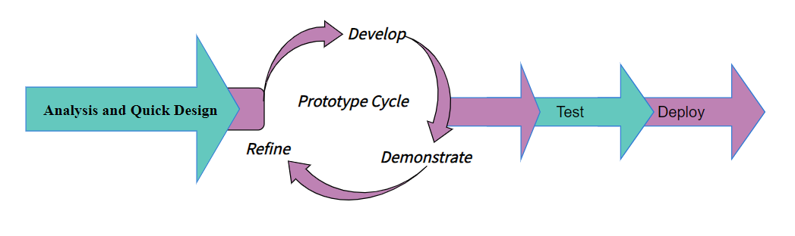
Figure 1Software Engineering Paradigm applied

2.5.1. Defining the Requirements
In the beginning, instead of following the usual way of making a detailed list of what the software should do with the users, we started with a basic idea of what was needed. This idea grew into more specific details as we went along in the development process. We asked questions like how does the system function? What is the workflow? How can we divide the entire system into smaller parts that can operate on their own?

2.5.2. Prototype
During the development phase, we focused on creating prototypes with various features and functions quickly, rather than following a set of requirements. These prototypes were shared with clients for their input on what they liked and disliked. Often, these prototypes were quickly made to work, just to show off certain features without proper polish. The final product is only created during the finalization stage, where both the client and developer agree on the product.

2.5.3. Receive Feedback
In this stage, feedback was shared regarding what works well, what doesn’t, what’s effective, and what isn’t. This feedback isn’t just about functionality, it also includes visuals and interfaces. With this feedback in mind, the process of prototyping continues. These two steps are repeated until a final product is achieved that meets the requirements of both the developers and the client.

2.5.4. Finalize Software
At this point, we worked with the client to finalize the features, functions, looks, and how the software works. We make sure the software is stable, easy to use, and easy to maintain before giving it to the client. These aspects are crucial to ensure the client gets a reliable product.

2.6. Data Models

2.6.1. Data Flow Diagram
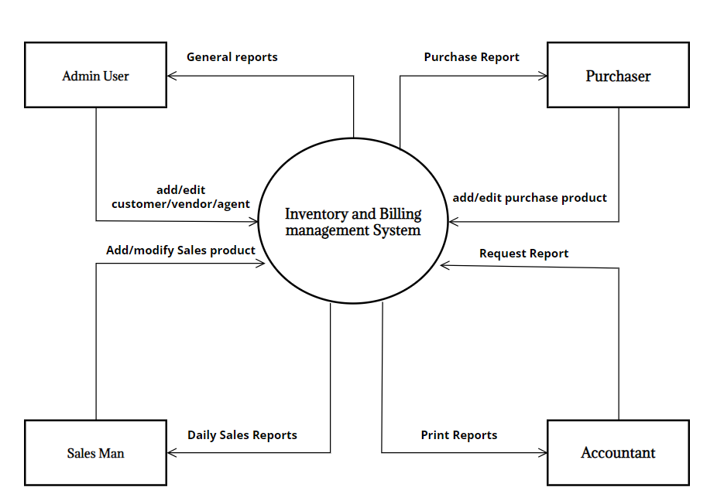
Figure 2 0 Level DFD for inventory and billing management
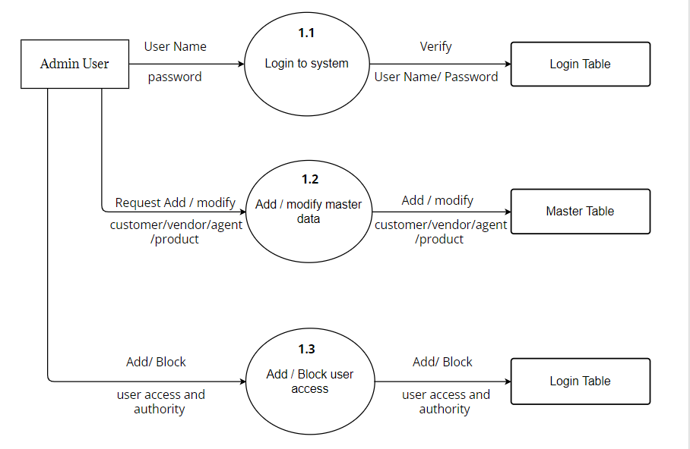
Figure 3 1 Level DFD for Admin User

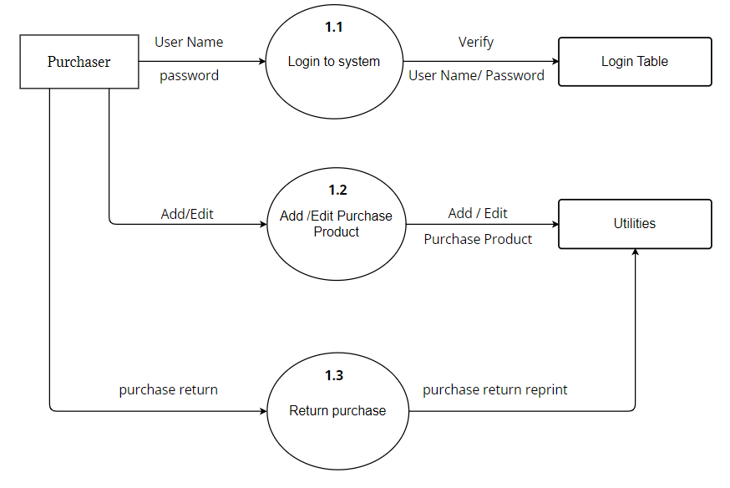
Figure 4 1 Level DFD for purchaser

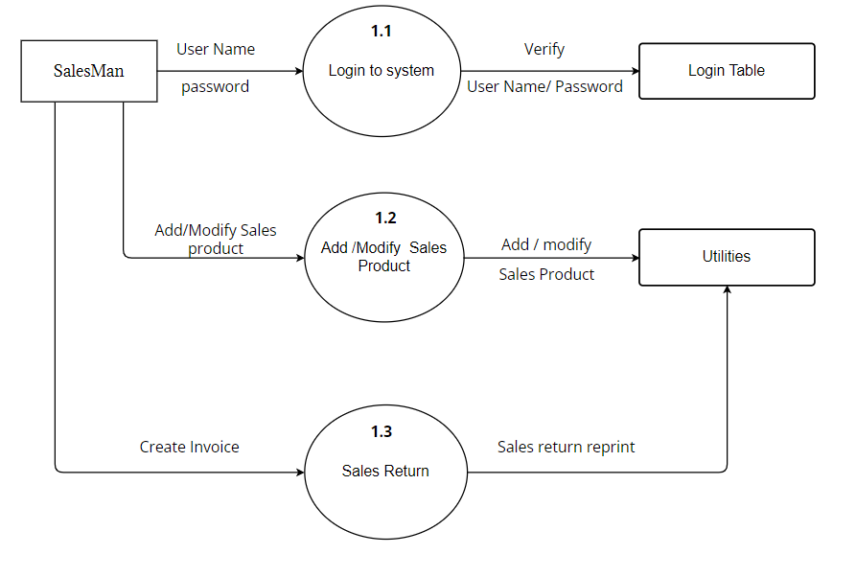
Figure 5 1 Level DFD for Sales Man

2.6.2. Control Flow Diagram
Figure 6 Control Flow diagram for Inventory and Billing (purchase)
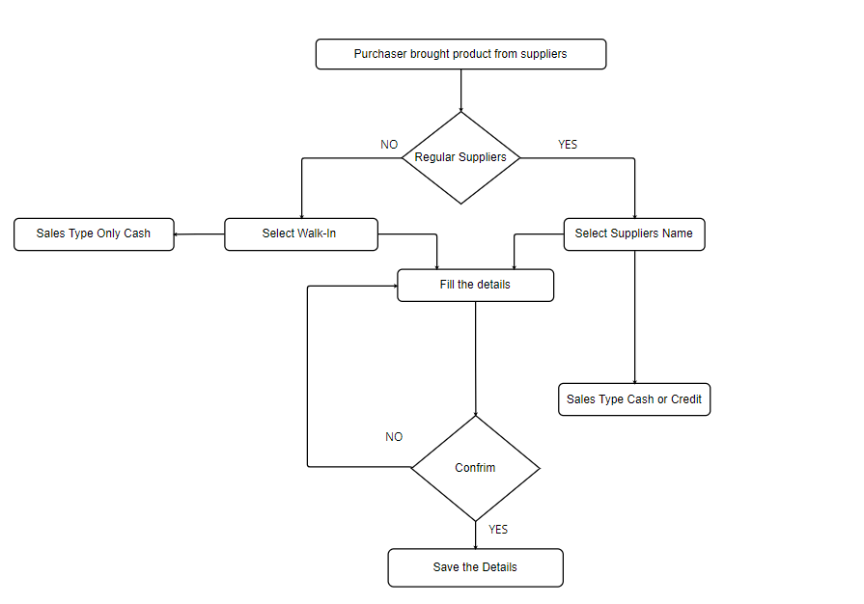

Figure 7 Control flow Diagram for Inventory and Billing (Sales)
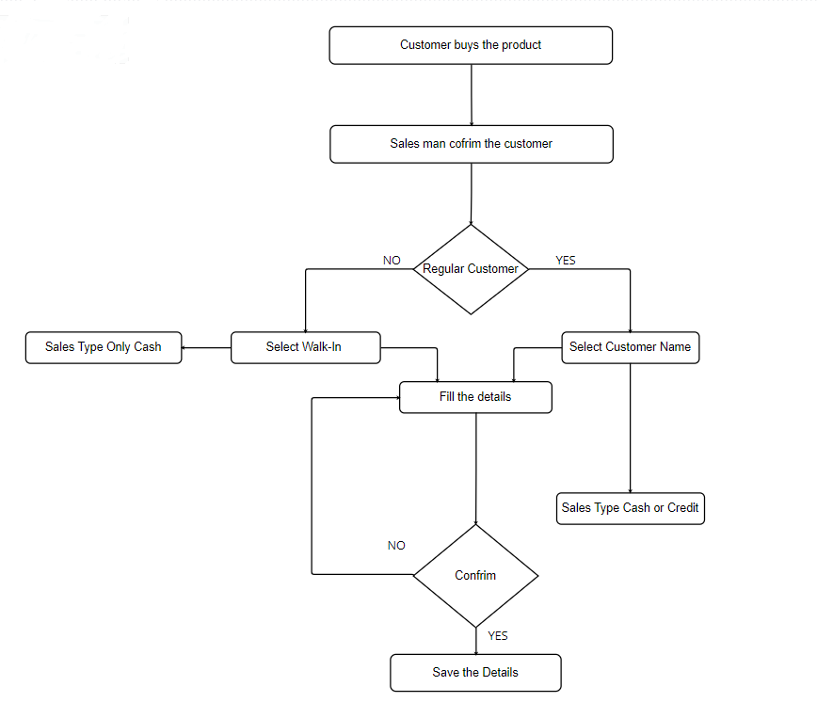

2.6.3. Entity Relationship Model
For the development of the system, initially, all the entities and their interrelation need to be identified. On the basis of that an ERD was developed, ERD consists of these components:
Rectangle : Represent entity sets
Ellipses : Represent attributes
Underline Ellipse : Represent Primary Key
Diamond : Represent relationship sets
Lines : Link attributes to entity sets to relationship sets

Figure 8 ER Diagram for Employee and Login
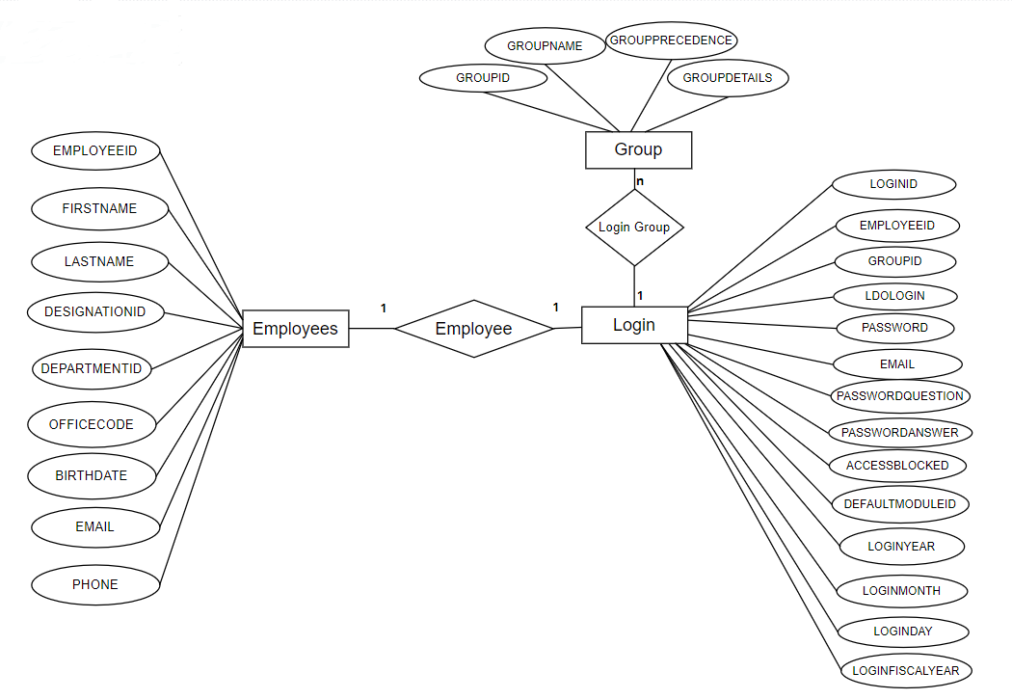

Figure 9 ER Diagram for Employee and Suppliers
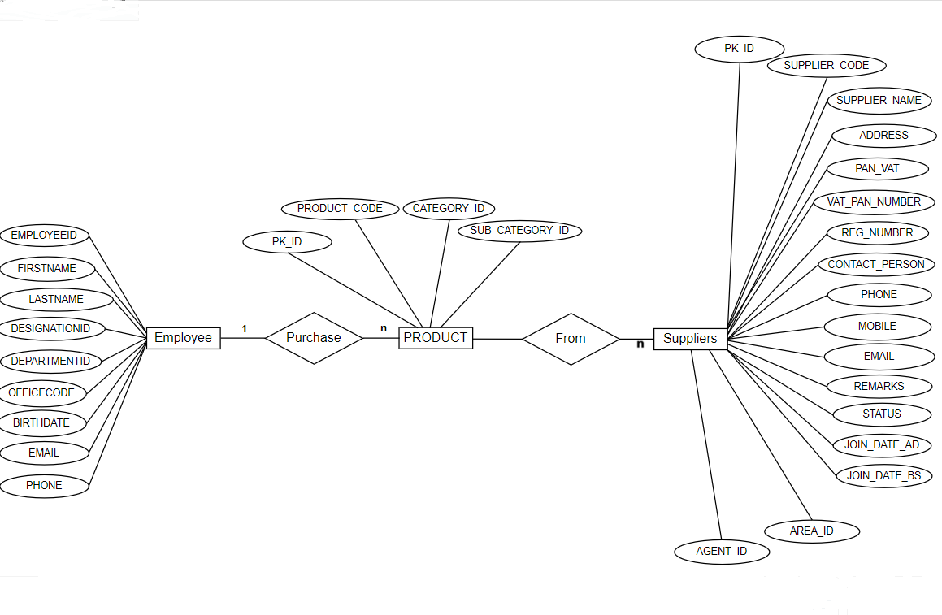

Figure 10 ER Diagram for Customer and Employee
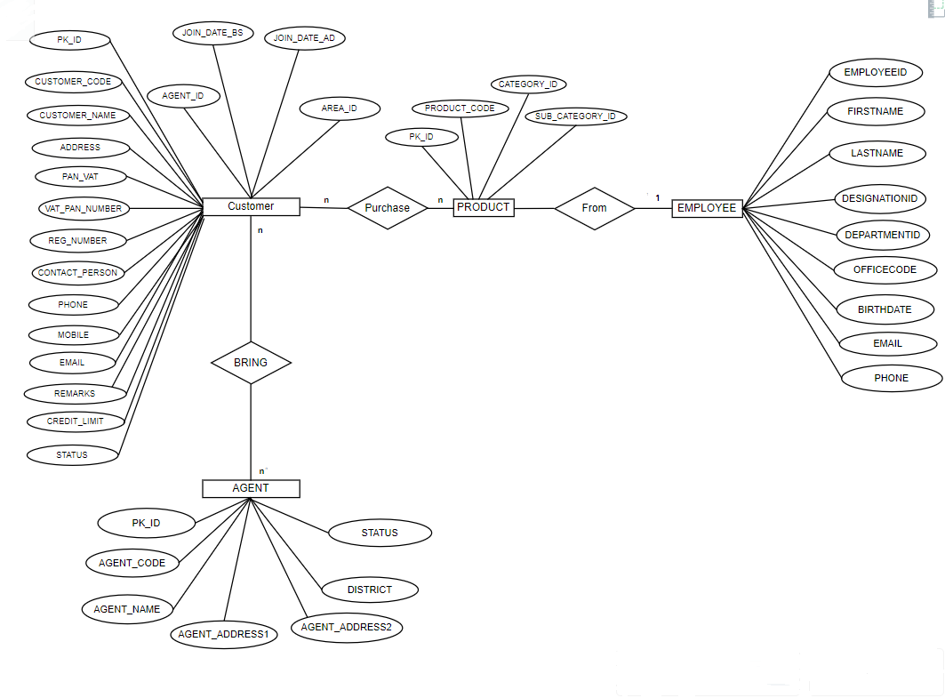

2.6.4. Use-Case Diagram

Figure 11 Use-Case Diagram for Admin User
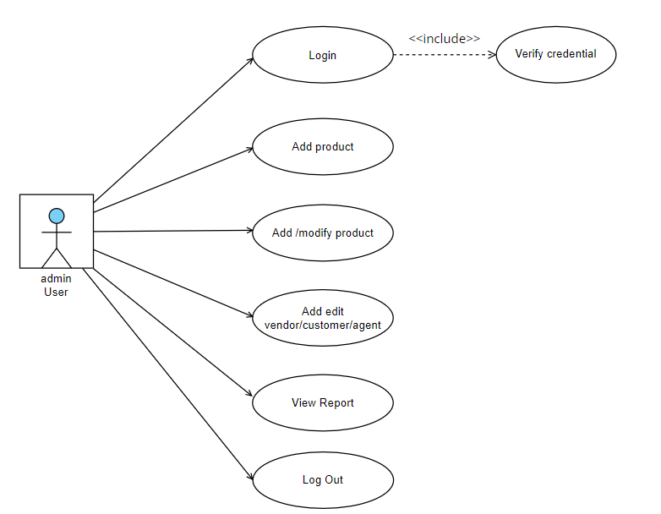

Figure 12 Use-case Diagram for purchaser
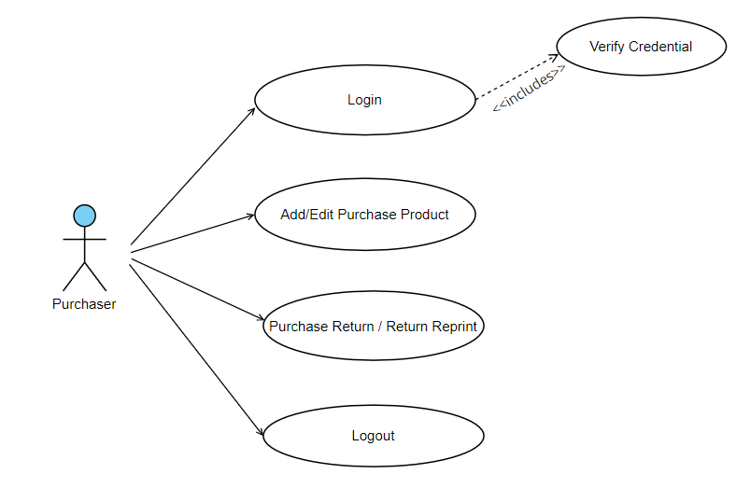
Figure 13 Use-case Diagram foe Sales man
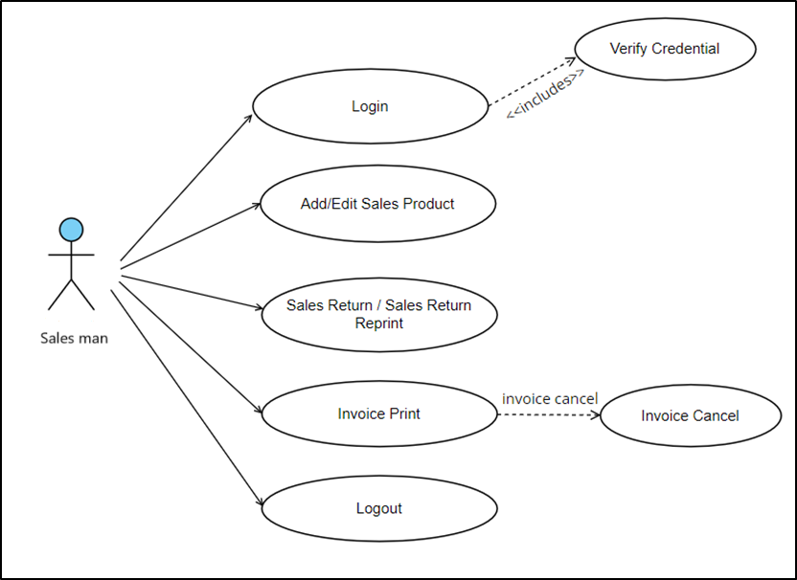

Figure 14 Use-case Diagram for Accountant
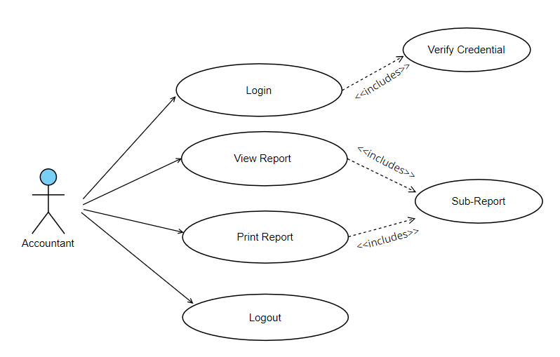

System Design

3.1. Modularization details

3.1.1. Master Data
In this module, the Admin user will have access to add and modify the menus available in the master data such as product unit, product group, product category, product, vendor, customer, agent, area, and license. This module is accessible only to the admin user. The data must be correct to generate correct reports and proper functioning of the system.

3.1.2. Utilities
This is the most important module where we have two sub-modules i.e. Purchase and Sales. In this module main activities are performed where purchase products are added, and edited, Sales products are added and modified and invoice is generated. Purchase returns and sale returns can be added and edited.

3.1.3. Reports
In this module, various reports are generated. The report module is divided into two sub-modules i.e. General and IRD. In general sub-module daily, monthly, yearly purchase and sales products reports are generated. All IRD-related reports are generated in the IRD sub-module.

3.2. Database Design, Data Integrity and Constraints
Table 2 Login
Column Name | ID | Key | Null? | Data Type
LOGINID | 1 | Primary | N | VARCHAR2 (100 Byte)
FULLDETAILS | 2 |  | Y | VARCHAR2 (50 Byte)
EMPLOYEEID | 3 |  | Y | NUMBER (8,2)
GROUPID | 4 |  | N | NUMBER (8,2)
LDOLOGIN | 5 |  | Y | DATE
PASSWORD | 6 |  | Y | VARCHAR2 (100 Byte)
EMAIL | 7 |  | Y | VARCHAR2 (50 Byte)
PASSWORDQUESTION | 8 |  | Y | VARCHAR2 (200 Byte)
PASSWORDANSWER | 9 |  | Y | VARCHAR2 (200 Byte)
ACCESSBLOCKED | 10 |  | Y | NUMBER (1)
DEFAULTMODULEID | 11 |  | Y | NUMBER (8,2)
LOGINYEAR | 12 |  | Y | VARCHAR2 (25 Byte)
LOGINMONTH | 13 |  | Y | VARCHAR2 (25 Byte)
LOGINDAY | 14 |  | Y | VARCHAR2 (25 Byte)
LOGINFISCALYEAR | 15 |  | Y | VARCHAR2 (25 Byte)
Table 3 Module
Column Name | ID | Key | Null? | Data Type
MODULEID | 1 | Primary | N | NUMBER (8,2)
MODULENAME | 2 |  | Y | VARCHAR2 (250 Byte)
LEAFNODE | 3 |  | Y | NUMBER (8,2)
PARENTMODULE | 4 |  | Y | NUMBER (8,2)
PICTURENAME | 5 |  | Y | VARCHAR2 (50 Byte)
REMARKS | 6 |  | Y | VARCHAR2 (400 Byte)
ORDERID | 7 |  | Y | NUMBER

Table 4 Sub-module
Column Name | ID | Key | Null? | Data Type
SUBMODULEID | 1 | Primary | N | NUMBER
SUBMODULE_NAME | 2 |  | N | VARCHAR2 (250 Byte)
MODULEID | 3 |  | Y | NUMBER
ORDER_BY | 4 |  | Y | NUMBER

Table 5 Sub-Module Permission
Column Name | ID | Key | Null? | Data Type
ID | 1 | Primary | N | NUMBER
GROUPID | 2 |  | Y | NUMBER
PERMISSION | 3 |  | Y | CHAR (8 Byte)
PAGENAME | 4 |  | Y | VARCHAR2 (20 Byte)

Table 6 Pages
Column Name | ID | Key | Null? | Data Type
PK_ID | 1 | PRIMARY | N | NUMBER
LINKNAME | 2 |  | Y | VARCHAR2 (200 Byte)
PAGENAME | 3 |  | Y | VARCHAR2 (400 Byte)
SUBMODULEID | 4 | FOREGIN | Y | NUMBER
SHOWINMODULE | 5 | FOREGIN | Y | VARCHAR2 (1 Byte)
ORDER_BY | 6 |  | Y | NUMBER

Table 7 Agent
Column Name | ID | Key | Null? | Data Type
PK_ID | 1 | PRIMARY | N | INTEGER
AGENT_CODE | 2 |  | Y | VARCHAR2 (50 Byte)
AGENT_NAME | 3 |  | Y | VARCHAR2 (200 Byte)
AGENT_ADDRESS1 | 4 |  | Y | VARCHAR2 (200 Byte)
AGENT_ADDRESS2 | 5 |  | Y | VARCHAR2 (100 Byte)
DISTRICT | 6 |  | Y | VARCHAR2 (50 Byte)
STATUS | 7 |  | Y | VARCHAR2 (50 Byte)
MOBILE | 8 |  | Y | VARCHAR2 (50 Byte)
EMAIL | 9 |  | Y | VARCHAR2 (50 Byte)
COMMISSION_PER | 10 |  | Y | INTEGER

Table 8 Area
Column Name | ID | Key | Null? | Data Type
PK_ID | 1 | PRIMARY | N | NUMBER
AREA_CODE | 2 |  | Y | VARCHAR2 (10 Byte)
AREA_NAME | 3 |  | Y | VARCHAR2 (50 Byte)

Table 9 Bank
Column Name | ID | Key | Null? | Data Type
PK_ID | 1 | Primary | N | INTEGER
BANK_CODE | 2 | Unique | Y | VARCHAR2 (20 Byte)
BANK_NAME | 3 |  | Y | VARCHAR2 (50 Byte)
BANK_ADDRESS | 4 |  | Y | VARCHAR2 (50 Byte)
ACCOUNT_TYPE | 5 |  | Y | VARCHAR2 (20 Byte)
ACCOUNT_NUMBER | 6 |  | Y | VARCHAR2 (20 Byte)
STATUS | 7 |  | Y | INTEGER

Table 10 Employee
Column Name | ID | Key | Null? | Data Type
EMPLOYEEID | 1 | Primary | N | VARCHAR2 (50 Byte)
FIRSTNAME | 2 |  | Y | VARCHAR2 (100 Byte)
LASTNAME | 3 |  | Y | VARCHAR2 (100 Byte)
DESIGNATIONID | 4 |  | Y | VARCHAR2 (100 Byte)
DEPARTMENTID | 5 |  | Y | VARCHAR2 (50 Byte)
OFFICECODE | 6 | Unique | Y | VARCHAR2 (20 Byte)
BIRTHDATE | 7 |  | Y | VARCHAR2 (50 Byte)
EMAIL | 8 |  | Y | VARCHAR2 (50 Byte)
PHONE | 9 |  | Y | VARCHAR2 (50 Byte)
MOBILE | 10 |  | Y | VARCHAR2 (50 Byte)
MARITALSTATUS | 11 |  | Y | VARCHAR2 (100 Byte)
GENDER | 12 |  | Y | VARCHAR2 (1 Byte)

Table 11 Customer
Column Name | ID | Key | Null? | Data Type
PK_ID | 1 | Primary | N | NUMBER
CUSTOMER_CODE | 2 | Unique | Y | VARCHAR2 (20 Byte)
CUSTOMER_NAME | 3 |  | Y | VARCHAR2 (100 Byte)
ADDRESS | 4 |  | Y | VARCHAR2 (100 Byte)
PAN_VAT | 5 |  | Y | VARCHAR2 (20 Byte)
VAT_PAN_NUMBER | 6 |  | Y | VARCHAR2 (50 Byte)
REG_NUMBER | 7 |  | Y | VARCHAR2 (50 Byte)
CONTACT_PERSON | 8 |  | Y | VARCHAR2 (100 Byte)
PHONE | 9 |  | Y | VARCHAR2 (50 Byte)
MOBILE | 10 |  | Y | VARCHAR2 (50 Byte)
EMAIL | 11 |  | Y | VARCHAR2 (100 Byte)
REMARKS | 12 |  | Y | VARCHAR2 (500 Byte)
CREDIT_LIMIT | 13 |  | Y | VARCHAR2 (50 Byte)
STATUS | 14 |  | Y | VARCHAR2 (20 Byte)
JOIN_DATE_AD | 15 |  | Y | DATE
JOIN_DATE_BS | 16 |  | Y | VARCHAR2 (20 Byte)
AREA_ID | 17 |  | Y | VARCHAR2 (10 Byte)
AGENT_ID | 18 |  | Y | VARCHAR2 (10 Byte)

Table 12 District
Column Name | ID | Key | Null? | Data Type
ID | 1 | Primary | N | VARCHAR2 (10 Byte)
DISTRICTNAME | 2 |  | Y | VARCHAR2 (50 Byte)
ZONEID | 3 |  | Y | VARCHAR2 (50 Byte)
PROVINCE_ID | 4 |  | Y | VARCHAR2 (50 Byte)

Table 13 Fiscal year
Column Name | ID | Key | Null? | Data Type
PK_ID | 1 | PRIMARY | N | NUMBER
FISCAL_YEAR | 2 |  | Y | VARCHAR2 (10 Byte)
ACTIVE | 3 |  | Y | NUMBER

Table 14 General ledger
Column Name | ID | Key | Null? | Data Type
PK_ID | 1 | PRIMARY | N | INTEGER
GL_CODE | 2 |  | Y | VARCHAR2 (20 Byte)
GL_NAME | 3 |  | Y | VARCHAR2 (100 Byte)
GL_TYPE | 4 |  | Y | VARCHAR2 (5 Byte)
GL_CONTROL_CODE | 5 |  | Y | VARCHAR2 (10 Byte)
PL_BS | 6 |  | Y | VARCHAR2 (5 Byte)
MASTER_PK_ID | 7 |  | Y | INTEGER
L_CASHBOOK | 8 |  | Y | INTEGER
L_CASHBANK | 9 |  | Y | INTEGER
STATUS | 10 |  | N | INTEGER

Table 15 Group
Column Name | ID | Key | Null? | Data Type
GROUPID | 1 | PRIMARY | N | NUMBER (8,2)
GROUPNAME | 2 |  | Y | VARCHAR2 (100 Byte)
GROUPPRECEDENCE | 3 |  | Y | NUMBER (8,2)
GROUPDETAILS | 4 |  | Y | VARCHAR2 (100 Byte)

Table 16 Log table
Column Name | ID | Key | Null? | Data Type
PK_ID | 1 | PRIMARY | Y | VARCHAR2 (50 Byte)
LOG_DATE | 2 |  | Y | DATE
LOG_TIME | 3 |  | Y | VARCHAR2 (50 Byte)
LOG_USER | 4 |  | Y | VARCHAR2 (100 Byte)
LOG_ACTION | 5 |  | Y | VARCHAR2 (100 Byte)
EFFECT_TABLE | 6 |  | Y | VARCHAR2 (100 Byte)
REF_NO | 7 |  | Y | VARCHAR2 (100 Byte)

Table 17 Office
Column Name | ID | Key | Null? | Data Type
PK_ID | 1 | PRIMARY | Y | VARCHAR2 (20 Byte)
OFFICECODE | 2 |  | Y | VARCHAR2 (100 Byte)
OFFICENAME | 3 |  | Y | VARCHAR2 (500 Byte)
WARDNO | 4 |  | Y | VARCHAR2 (25 Byte)
STREET | 5 |  | Y | VARCHAR2 (500 Byte)
VDCMUNICIPALITY | 6 |  | Y | VARCHAR2 (500 Byte)
OFFICETYPEID | 7 |  | Y | VARCHAR2 (50 Byte)
WORKSASDEPOT | 8 |  | Y | VARCHAR2 (50 Byte)
REGIONID | 9 |  | Y | VARCHAR2 (100 Byte)
CONTACT_PERSON | 10 |  | Y | VARCHAR2 (100 Byte)
PHONE_NO | 11 |  | Y | VARCHAR2 (50 Byte)
MOBILE_NO | 12 |  | Y | VARCHAR2 (50 Byte)
EMAIL | 13 |  | Y | VARCHAR2 (100 Byte)

Table 18 Office type
Column Name | ID | Key | Null? | Data Type
OFFICETYPEID | 1 | Primary | N | NVARCHAR2 (20)
OFFICETYPENAME | 2 |  | Y | NVARCHAR2 (50)
DETAILS | 3 |  | Y | NVARCHAR2 (200)
Table 19 Opening Balance
Column Name | ID | Key | Null? | Data Type
PK_ID | 1 | PRIMARY | N | NUMBER
PRODUCT_ID | 2 |  | Y | NUMBER
EXPIRY_DATE | 3 |  | Y | DATE
COLOUR_ID | 4 |  | Y | NUMBER
SIZE_ID | 5 |  | Y | NUMBER
MANUFACTURER_ID | 6 |  | Y | NUMBER
BATCH_NUMBER | 7 |  | Y | VARCHAR2 (20 Byte)
FISCAL_YEAR | 8 |  | Y | VARCHAR2 (10 Byte)
QUANTITY | 9 |  | Y | NUMBER

Table 20 Product
Column Name | ID | Key | Null? | Data Type
PK_ID | 1 | PRIMARY | N | NUMBER
PRODUCT_CODE | 2 |  | N | VARCHAR2 (50 Byte)
CATEGORY_ID | 3 |  | Y | NUMBER
SUB_CATEGORY_ID | 4 |  | Y | NUMBER
PRODUCT_NAME | 5 |  | Y | VARCHAR2 (100 Byte)
PACK_QTY | 6 |  | Y | VARCHAR2 (20 Byte)
UNIT_ID | 7 |  | Y | NUMBER
PRICE_CATEGORY | 8 |  | Y | VARCHAR2 (20 Byte)
EXPIRY_STATUS | 9 |  | Y | VARCHAR2 (20 Byte)
STATUS | 10 |  | Y | VARCHAR2 (20 Byte)
COLOUR_STATUS | 11 |  | Y | NUMBER
SIZE_STATUS | 12 |  | Y | NUMBER
MANUFACTURE_STATUS | 13 |  | Y | NUMBER
BATCH_STATUS | 14 |  | Y | NUMBER
TAX_STATUS | 15 |  | Y | NUMBER
DUAL_UNIT | 16 |  | Y | NUMBER
UPPER_UNIT_ID | 17 |  | Y | NUMBER

Table 21 Product Category
Column Name | ID | Key | Null? | Data Type
PK_ID | 1 | PRIMARY | Y | NUMBER
CATEGORY_CODE | 2 |  | Y | VARCHAR2 (40 Byte)
CATEGORY_NAME | 3 |  | Y | VARCHAR2 (40 Byte)
STATUS | 4 |  | Y | VARCHAR2 (20 Byte)

Table 22 Product sub-category
Column Name | ID | Key | Null? | Data Type
PK_ID | 1 | PRIMARY | Y | NUMBER
CATEGORY_ID | 2 |  | Y | NUMBER
SUB_CATEGORY_CODE | 3 |  | Y | VARCHAR2 (40 Byte)
SUB_CATEGORY_NAME | 4 |  | Y | VARCHAR2 (40 Byte)
STATUS | 5 |  | Y | VARCHAR2 (40 Byte)

Table 23 Product Unit
Column Name | ID | Key | Null? | Data Type
PK_ID | 1 | PRIMARY | N | NUMBER
UNIT_NAME | 2 |  | Y | VARCHAR2 (200 Byte)

3.3. Test Cases

3.3.1. Unit Testing
Unit Testing is done to check whether the individual modules of the source code are working properly i.e. testing every unit of the application separately by the developer in the developer’s environment. It is known as Module Testing or Component Testing.

3.3.2. Integration Testing
Integration Testing checks if different parts of a software work well together. It verifies that individual units, previously tested separately, function correctly when combined. It focuses on interaction between components like data flow and communication. By testing integration points, developers find defects early and ensure the system operates smoothly.

3.3.3. System Testing
System Testing is a black box testing. It is a stage in software testing where the complete software system is evaluated to ensure it function properly according to its requirements. It involves testing the integrated software components and their interactions to validate that the system behaves as expected. It assesses the system’s functionality, performance, reliability, and compliance.

3.3.4. Acceptance Testing
Acceptance testing is the final check for software before it goes live. It ensures the software meets user needs and follows business rules. It is like getting a thumbs-up from users and stakeholders, saying “Yes, it’s ready!” It involves testing the software from the user’s viewpoint to ensure it works as expected before launching. Types of Acceptance Testing are Alpha and Beta Testing.

3.3.4.1. Alpha Testing
Alpha Testing is like performing usability testing, which is normally done by the in-house developers. On rare occasions Alpha Testing is done by the client or an outsider. Once the alpha testing version is released, it’s then called the Alpha Release.

3.3.4.2. Beta Testing
Beta Testing is done by the number of end users before delivery, the change request would be fixed if the user gives the feedback or reports defects. The Version Release after beta testing is called beta Release.
Table 24 Standard Test Case Format
Test Case ID | T1.01 refers to the test case for the first module whereas T2.01 refers to the test case for the second module
Test Scenario | It is a scenario for a test case eg: Verify that the user can log in with the valid data
Expected Outcome | The output must be matched with the actual outcome
Status | “Pass/Fail”, If the output matches with the expected result then it passes the test else Fail.

Table 25 Unit test case
Test Case ID | Test Scenarios | Expected Outcome | Status | Comments
T1.01 | Verify that the unit name can be added | Users can add product unit | Pass
T1.02 | Verify that the unit name can edit | Users can edit product unit | Pass
T1.03 | Verify whether the status has an active or inactive option | The status must have two dropdown options i.e. active and inactive | Pass
T1.04 | Verify whether the group code is generated within the group name | The group code is generated within the group name | Pass
T1.05 | Verify that group name and status can change after the edit button is clicked | Once the group name is added, its status can be edited by clicking on the edit button | Pass
T1.06 | Verify whether the added product group is generated within the product category | The available product groups are generated automatically in the select dropdown menu within the product category | Pass
T1.07 | Verify that the category code is generated within the category | Category code is generated automatically within the product category | Pass
T1.08 | Display an error if the 'Add Product' table is saved empty | The pop-up message is displayed if the empty table is saved | Pass
T1.09 | Verify that users can add/edit Vendors | Users can add/ edit vendor's details | Pass
T1.10 | Verify that users can add/edit Customers | Users can add/ edit vendors' details | Pass
T1.11 | Verify that users can add/edit Agents | Users can add/ edit agent's details | Pass

Table 26 Test Case for sub-module Purchase
Test Case ID | Test Scenarios | Expected Outcome | Status |  | Comments
T2.01 | Verify that when the 'Walk In' button is clicked, the sales type is only cash | The sales type is always cash if the product is purchased from walk-in suppliers | Pass
T2.02 | Check if the invoice date and dakhila date are generated automatically | The invoice date and dakhila date must be generated automatically | Pass
T2.03 | Verify that entering the supplier's name generates the supplier code automatically | If we select a supplier's name, the supplier code is generated automatically | Pass
T2.04 | Verify that entering the supplier's code generates the supplier name automatically | If we select a supplier's code, the supplier name is generated automatically | Pass
T2.05 | Verify that the sales type is either cash or credit during regular purchases | If 'walk-in' is not selected and a regular purchase is made, then the sales type must be either cash or credit | Pass
T2.06 | Verify that entering the code generates the product name automatically | If we select a code, the product name is generated automatically | Pass
T2.07 | Verify that selecting the product generates the product code automatically | If we select a product name, the product code is generated automatically | Pass
T2.08 | Verify that by entering the quantity and product rate, the amount is generated automatically | Amount is generated automatically after quantity and rate is provided | Pass
T2.09 | Check that the purchase details are added | Purchase details are added in the purchase detail section before being saved | Pass
T2.10 | Change the VAT Percent | The amount changes according to the VAT percentage | Fail |  | The 13%VAT percent is fixed
T2.11 | Verify that the details of purchased products can be edited | The purchase product can be edited after the edit button is clicked | Pass
T2.12 | Verify that the details of returned purchased products can be added | Return products are added after clicking on the edit button | Pass
T2.13 | Verify that the purchase return debit note is generated properly | The debit note is generated after clicking on the print button | Pass

Table 27 Test Case for sub-module Sales
Test Case ID | Test Scenarios | Expected Outcome | Status | Comments
T2.014 | Verify that when the 'Walk In' button is clicked, the sales type is only cash | The sales type is always cash if the product is sold to a walk-in customer | Pass
T2.015 | Check if the invoice type is Tax invoice or Exempted invoice | Invoice type must be Tax invoice or Exempted invoice | Pass
T2.016 | Check that the agent name is available and can be selected | The agent name must be available | Pass
T2.017 | Verify only tax invoice products displayed in the product name when tax invoice type is selected | Tax invoice products are displayed in the product name | Pass
T2.018 | Check if any errors occur when entering an invalid PAN /VAT number | The message must pop up as "Not a valid PAN/VAT Number", The PAN/VAT number must be 9 digits | Pass
T2.019 | Verify that entering the customer's name generates the customer code automatically | If we select a customer's name, the customer code is generated automatically | Pass
T2.020 | Verify that entering the customer's code generates the customer name automatically | If we select a customer's code, the customer name is generated automatically | Fail | Result: error occurred
T2.021 | Verify whether the sales type is only cash for walk-in customers | The sales type must be cash only for walk-in customers | Pass

Procedural Design
In this project, four different packages are defined. Each package is designed for specific use. The package contains sub-programs as procedures and functions that consist of a group of PL/SQL statements with unique names. The list of packages defined in the project are:

- PKJ_MODIFY
This package is defined for user access. This package consists of procedures like
- MODIFY_FISCALYEAR
- MODIFY_BANK
- MODIFY_PAYMENT_TYPE
- MODIFYLOGIN
- MODIFYEMPLOYEES
- MODIFY_NAME_COMPANY
- MODIFY_CUSTOMER
- MODIFY_PRODUCT
- MODIFY_PURCHASE_CHALAN_MASTER
- MODIFY_PURCHASE_CHALAN_DETAIL
- MODIFY_PURCHASE_INVOICE_MASTER
- MODIFY_PURCHASE_RETURN_MASTER
- MODIFY_SALES_INVOICE_MASTER
- PKJ_REPORTS
- GET_CATEGORY_CODE
- GET_PRODUCT_NAME
- PURCHASE_REPORT
- PURCHASE_LIST
- DEBIT_NOTE_LIST
- SALES_LIST
- SALES_REPORT
- PURCHASE_RETURN_LIST
- SALES_RETURN_LIST
- CREDIT_NOTE_LIST
- ADJUSTMENT_REPORT
- GET_IRD_REPORT

- PKJ_SELECT
- SELECT_DISTRICT
- SELECT_PROVINCE
- SELECT_ZONE
- SELECT_FISCALYEAR
- SELECT_BANK
- SELECT_PAYMENT_TYPE
- SELECT_CLOSING_STATUS
- SELECT_EMPLOYEE
- SELECTPASSWORD_RESENT
- SELECT_MODULE
- SELECT_SUBMODULE
- SELECT_PAGES
- SELECT_NAME_COMPANY
- SELECT_SUPPLIERS
- SELECT_CUSTOMER
- SELECT_PRODUCT_SUB_CATEGORY
- SELECT_PRODUCT_COLOUR
- SELECT_PRODUCT_MANUFACTURE
- SELECT_PRODUCT_SIZE
- SELECT_PURCHASE_CHALAN_MASTER
- SELECT_PURCHASE_CHALAN_DETAIL
- SELECT_PURCHASE_INVOICE_MASTER
- SELECT_PURCHASE_RETURN_MASTER
- SELECT_SALES_CHALAN_MASTER
- SELECT_SALES_INVOICE_MASTER
- SELECT_SALES_RETURN_MASTER

- PKJ_USERACCESS
- GET_USERPROFILE
- GET_SUBMODULE
- GET_LINKNAME
- GET_PAGENAME
- GET_MODULE
- GET_LINKNAMEPARENT

System Security measures

4.1. Database/data security
- For the security of the database different triggers are made so that no one can insert, update or delete the data from the database.
- All the logs are maintained whatever changes are made in database.
- Separate archive log of database is maintained for recovery of database
- Daily auto backup of database is maintained from task scheduler.
- Different triggers are maintained to prevent alteration in data of database.

4.2. List of triggers to maintain log
Trigger | Table
LOG_CREATE_CREDIT_NOTE | SALES_RETURN_MASTER
LOG_CREATE_INVOICE | SALES_INVOICE_MASTER
LOG_PRINT_INVOICE | SALES_INVOICE_MASTER
LOG_PRODUCT_ADJUSTMENT | PRODUCT_ADJUSTMENT
LOG_PURCHASE | PURCHASE_INVOICE_MASTER
LOG_PURCHASE_RETURN | PURCHASE_RETURN_MASTER

4.3. List of triggers to preventive Data manipulation
Trigger | Table
DML_ADBS | ADBS
DML_LOGIN_LOG | LOGIN_LOG
DML_LOG_TABLE | LOG_TABLE
DML_NAME_COMPANY | NAME_COMPANY
DML_P_INVOICE_DETAIL | PURCHASE_INVOICE_DETAIL
DML_P_INVOICE_MASTER | PURCHASE_INVOICE_MASTER
DML_P_RETURN_DETAIL | PURCHASE_RETURN_DETAIL
DML_P_RETURN_MASTER | PURCHASE_RETURN_MASTER
DML_PRODUCT_ADJUSTMENT | PRODUCT_ADJUSTMENT
DML_S_RETURN_DETAIL | SALES_RETURN_DETAIL
DML_S_RETURN_MASTER | SALES_RETURN_MASTER
DML_SALES_INVOICE_DETAIL | SALES_INVOICE_DETAIL
DML_SALES_INVOICE_MASTER | SALES_INVOICE_MASTER

